On the Beat in
Bridgnorth and Rural East
Safer Neighbourhood Team |  |  |  |  |  | December 2022
Where we Work
The Safer Neighbourhood Team are based in Bridgnorth Police Station, Wenlock Road, Bridgnorth, Shropshire, WV16 5BB. We work in Bridgnorth, and the parishes of Alveley Claverley Worfield and Ackleton.
Team contact details
Team email: bridgnorth.snt@westmercia.pnn.police.uk
Safer Neighbourhood Officer | Police Community Support Officer |  | Police Community Support Officer |  |  |  | Police Community Support Officer
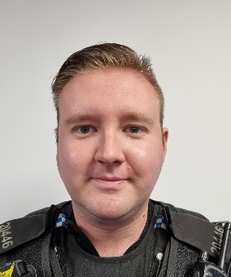 | 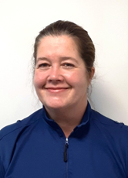 |  |  |  |  |  | 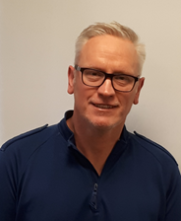
PC Jono Lightfoot | PCSO Mandy Leek |  | PCSO Helen Oakley |  |  |  | PCSO Stephen Dunn-Brown
07811761855 | 07816236749 |  | 07816237839 |  |  |  | 07814053796
Police Contact Details
Emergency: 999 |  |  |  |  | Website: www.westmercia.police.uk
Non Emergency: https://www.westmercia.police.uk/ |  |  |  |  | Twitter: @Bridgnorthcops
Crime stoppers: 0800 555 111 or
https://crimestoppers-uk.org/give-information/forms/give-information-anonymously
Facebook: Shropshire Cops
This monthly newsletter aims to bring you news of Police activity in your local area, events that the team have attended or are hoping to attend and useful information, such as crime prevention advice. We hope it is of use and would like to hear from you if you have any ideas on what to include or how we can improve this publication. We look forward to hearing from you.
Sign up to Neighbourhood Matters … your brand new community messaging service
 |  | Neighbourhood Matters enables residents, businesses and community groups to keep in touch with local policing teams. You can choose exactly what type of alert you wish to receive and how you receive them; whether that be by email, text or telephone. Sign up now at: www.neighbourhoodmatters.co.uk
Frosty Mornings. Don’t be tempted on a frosty morning to leave your car unattended while the engine is running to defrost the windows. Each year we have a number of reports of cars being stolen while their owners left the engine running and then went back inside their house while the windscreen was defrosting. It only takes a moment for someone to get into your car and drive off, it really is not worth the risk. |  |  |  | 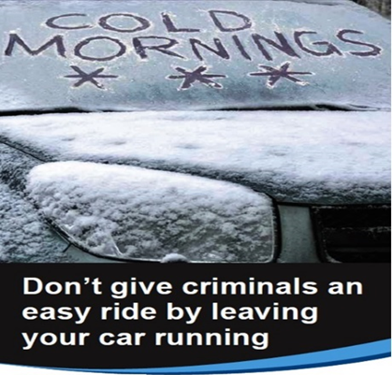
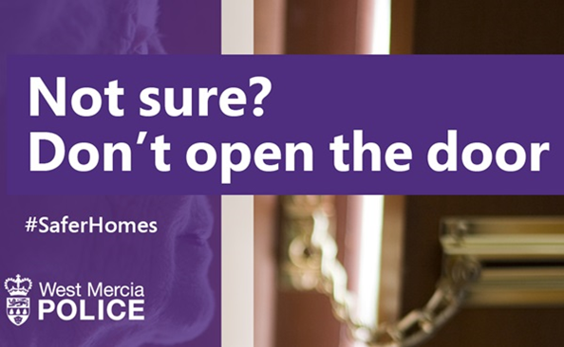 |  |  |  | Door to Door Pedlars. We have received a number of reports recently regarding door to door sales people claiming to be working as part of an ex offender rehabilitation scheme. There is no such scheme run by the probation service and these people are making the claim to try and get your sympathy and your money. Police advice is to either not answer the door, or to politely and firmly decline their products and close your door.
Engagement & Activity During November we have attended two bonfire and fireworks displays in Bridgnorth and Claverley.  Pc Lighfoot attended both secondary schools and gave talks to students on hate crime harassment and Bullying.  Another session of Police cadets has commenced at St Leonards school.  Pcso Leek Seized a vehicle that was untaxed, uninsured and with no current Mot from Innage lane after concerned residents reported it.  Operation Sceptre took place this month which is around Knife crime, knife sweeps took place around town and across Shropshire along with talks in the schools. No knives were found during the searches. |  |  |  | 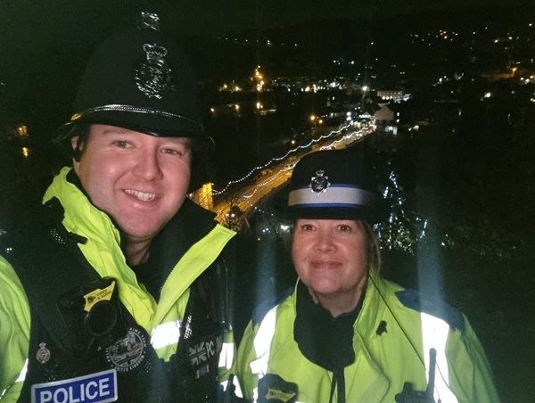  Lastly the team attended the Christmas Light switch on in Town we were joined by colleagues from Shifnal Albrighton, Highley and Cleobury, Wenlock Broseley and two of Westmercia’s finest specials
Officers from the team will be attending further Town and Parish Council Meetings in the coming months and hosting other engagement meetings, including use of the Mobile Police Station.

