On the Beat in
Bridgnorth and Rural East
Safer Neighbourhood Team |  |  |  |  |  | Month Year
Where we Work
The Safer Neighbourhood Team are based in Bridgnorth Police Station, Wenlock Road, Bridgnorth, Shropshire, WV16 5BB. We work in Bridgnorth, and the parishes of Alveley Claverley Worfield and Ackleton.
Team contact details
Team email: bridgnorth.snt@westmercia.pnn.police.uk
Safer Neighbourhood Officer | Police Community Support Officer |  |  | Police Community Support Officer |  |  |  | Police Community Support Officer
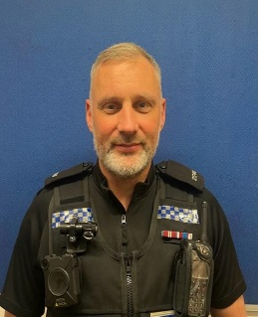 | 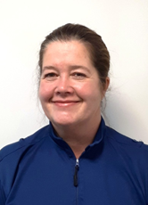 |  |  | 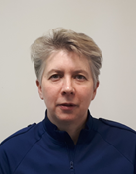 |  |  |  | 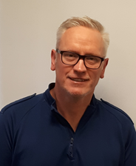
PC Rikki LOFTUS | PCSO Mandy Leek |  |  | PCSO Helen Oakley |  |  |  | PCSO Stephen Dunn-Brown
07967302226 | 07816236749 |  |  | 07816237839 |  |  |  | 07814053796
Police Contact Details
Emergency: 999 |  |  |  |  | Website: www.westmercia.police.uk
Non Emergency: https://www.westmercia.police.uk/ |  |  |  |  | Twitter: @Bridgnorthcops
Crime stoppers: 0800 555 111 or
https://crimestoppers-uk.org/give-information/forms/give-information-anonymously
Facebook: Shropshire Cops
This monthly newsletter aims to bring you news of Police activity in your local area, including Crime Alerts, positive action that has been taken by the Police, future public meetings and events that the team are hoping to attend and useful information, such as crime prevention advice. We hope it is of use and would like to hear from you if you have any ideas on what to include or how we can improve this publication. We look forward to hearing from you, the team email is the best point of contact.
Sign up to Neighbourhood Matters … your brand new community messaging service
 |  | Neighbourhood Matters enables residents, businesses and community groups to keep in touch with local policing teams. You can choose exactly what type of alert you wish to receive and how you receive them; whether that be by email, text or telephone. Sign up now at: www.neighbourhoodmatters.co.uk
Welcome. We would like to welcome to the team PC Rikki LOFTUS. He joined us at the beginning of December and has been busy meeting our partner agencies and members of the public. Rikki has taken over the role from PC Jono LIGHTFOOT who has moved on to the Rural crime team in Shrewsbury. We wish them both luck in their new roles. |  |  |  |  |  |  | 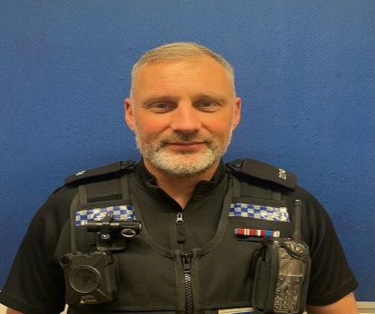
Young Cadets. Year 6 cadets at St. Leonards school will be finishing their 6 week course at the beginning of January. They will have a passing out parade to celebrate.  Christmas Market  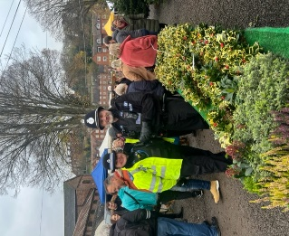  PC LOFTUS and PCSO LEEK attended the Christmas market at Bridgnorth Rugby Club. It was great to speak to so many members of the public. There was a fantastic Christmassy atmosphere.  Dates for your diary.  9th Jan 10-12 Armed forces OutReach Bridgnorth Library. |  |  | StreetSafe is a pilot service for anyone to anonymously tell us about public places where you have felt or feel unsafe, because of environmental issues, eg street lighting, abandoned buildings or vandalism and/or because of some behaviours, eg being followed or verbally abused.  Please note: 'StreetSafe' is not for reporting crime or incidents.  If something has happened to you or someone you know (including in public spaces) let us know using the online ‘Tell Us About’ form on our website www.westmercia.police.uk.  If you aren’t comfortable contacting us directly, you can pass on information anonymously to the independent charity, Crimestoppers, by calling 0800 555 111 or by visiting their website: www.crimestoppers-uk.org  If you ever feel at risk, or a crime is in progress, please always dial 999.  Thank you for your help. It is only by the police and the public working together that we can prevent crime and make our streets safer.  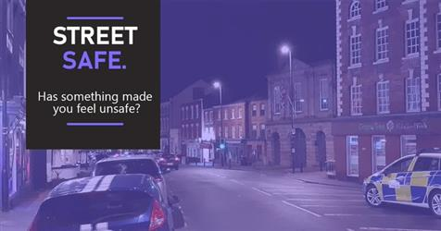
Officers from the team will be attending further Town and Parish Council Meetings in the coming months and hosting other engagement meetings, including use of the Mobile Police Station.
Bridgnorth Safer Neighbourhood Team would like to wish you all a Very Happy New Year. Hopefully it is filled with joy and good times.

