On the Beat in
Bridgnorth and Rural East
Safer Neighbourhood Team |  |  |  |  |  | Month Year
Where we Work
The Safer Neighbourhood Team are based in Bridgnorth Police Station, Wenlock Road, Bridgnorth, Shropshire, WV16 5BB. We work in Bridgnorth, and the parishes of Alveley Claverley Worfield and Ackleton.
Team contact details
Team email: bridgnorth.snt@westmercia.pnn.police.uk
Safer Neighbourhood Officer | Police Community Support Officer |  |  | Police Community Support Officer |  |  |  | Police Community Support Officer
 | 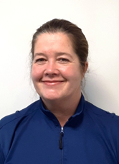
PC Jono Lightfoot | PCSO Mandy Leek |  |  | PCSO Helen Oakley |  |  |  | PCSO Stephen Dunn-Brown
07811761855 | 07816236749 |  |  | 07816237839 |  |  |  | 07814053796
Police Contact Details
Emergency: 999 |  |  |  |  | Website: www.westmercia.police.uk
Non Emergency: https://www.westmercia.police.uk/ |  |  |  |  | Twitter: @Bridgnorthcops
Crime stoppers: 0800 555 111 or
https://crimestoppers-uk.org/give-information/forms/give-information-anonymously
Facebook: Shropshire Cops
This monthly newsletter aims to bring you news of Police activity in your local area, including Crime Alerts, positive action that has been taken by the Police, future public meetings and events that the team are hoping to attend and useful information, such as crime prevention advice. We hope it is of use and would like to hear from you if you have any ideas on what to include or how we can improve this publication. We look forward to hearing from you, the team email is the best point of contact.
Sign up to Neighbourhood Matters … your brand new community messaging service
 |  | Neighbourhood Matters enables residents, businesses and community groups to keep in touch with local policing teams. You can choose exactly what type of alert you wish to receive and how you receive them; whether that be by email, text or telephone. Sign up now at: www.neighbourhoodmatters.co.uk
Positive Action. The team have had a number of reports from members of the public who have been affected by cars being driven or used in an anti-social manner lapping the town and other roads in the close locality. As a result of these reports we have had the support of our roads policing team monitoring and engaging with any offending vehicles seen to be driving in an antisocial manner. |  |  |  |  |  |  | 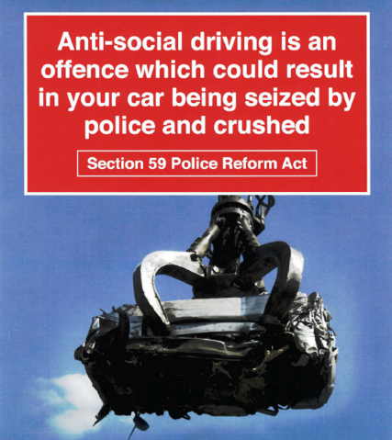
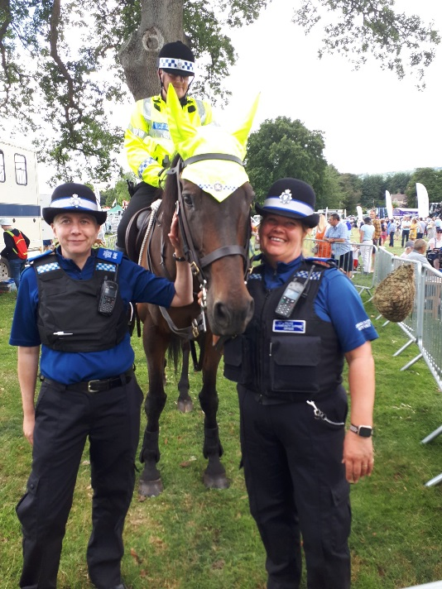 |  |  | Engagement. In August , Officers from the team engaged in the community with routine patrol activity across our town and Parish’s and also attended a number of meetings and Community Events, including the Mp’s hustings at Ludlow racecourse , the Quatt ParishCouncil Meeting, the annual Burwarton show, the Forces outreach at Bridgnorth Library . The leavers party at Worfield primary school and St Marys school Fete and Family Fun Day . We attended the Baton Relay when it came through Bridgnorth town we also assisted colleagues in Shrewsbury when the Queens Baton Relay for the Commonwealth Games came through their town too. This is to name but a few of the things we have been up to.
Officers from the team will be attending further Town and Parish Council Meetings in the coming months and hosting other engagement meetings, including use of the Mobile Police Station.
The team are looking forward to engaging with our local schools in the new term.

